1. Use the text-decoration-style property to achieve the following effects：

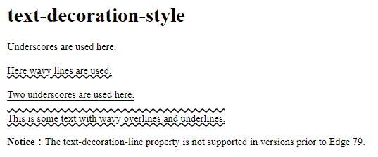

Reference answer: text-decoration-style.html

1. Example of setting font size with em:

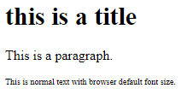

Reference answer: Example of setting font size with em.html

1. Set different font styles for three paragraphs:

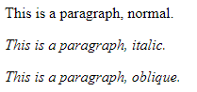

Reference answer: Example of setting font size with em.html

1. Achieve the following effects:

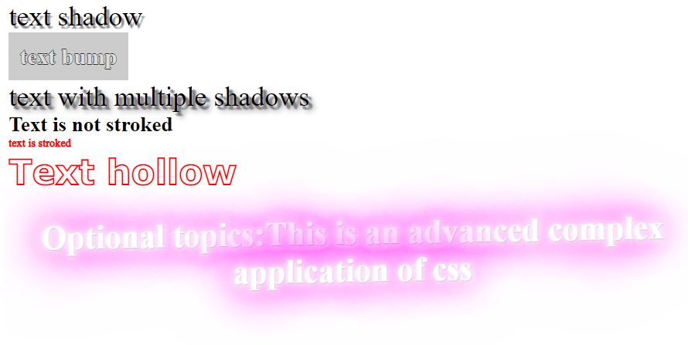

Reference answer: Achieve the following effects.html

1. Refer to learn the example below (Note: The image changes when the mouse is over the image):

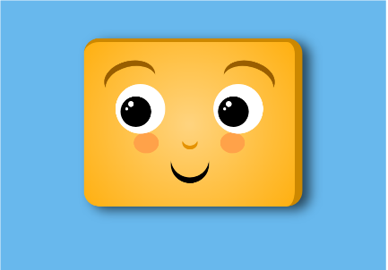 

Reference answer: Refer to learn the example.html

1. draw an egg with css:



Reference answer: draw an egg.html

1. Implementing a waterfall layout:

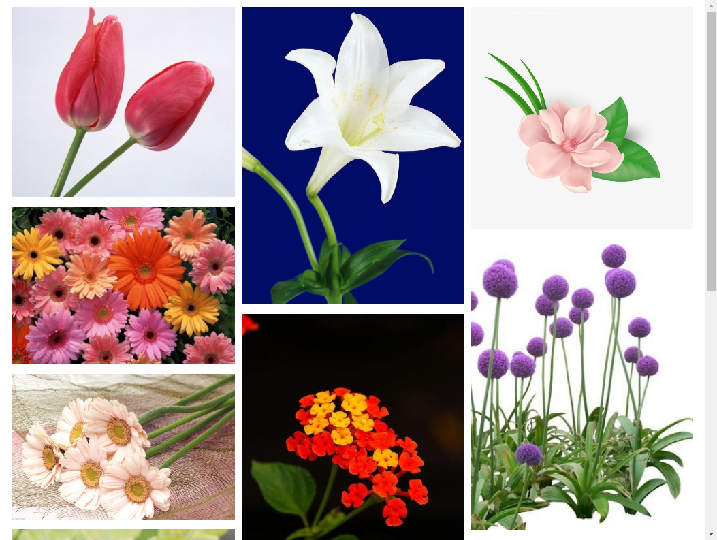

Reference answer: Waterfall layout.html.html